CHAPTER 3
PROPOSED SYSTEM
A hybrid deep learning architecture is developed to enhance the automated detection of depression from EEG signals. The proposed system combines the strengths of Convolutional Neural Networks (CNN) for spatial feature extraction and Long Short-Term Memory (LSTM) networks for temporal sequence learning. This hybrid design addresses the limitations of CNNs in capturing long-term dependencies in time-series data such as EEG, thereby achieving more comprehensive signal interpretation.
- Feature Extraction Using CNN
The CNN component is responsible for extracting spatial features from the multi-channel EEG input. CNN employs a convolution operation, where a set of learnable filters (kernels) slide over the input matrix to produce feature maps. In the proposed model, a kernel size of 64 × 5 is used, selected based on its ability to capture frequency components of 4 Hz and above, which are relevant in EEG analysis for mental health conditions. A ReLU (Rectified Linear Unit) activation function follows the convolution operation, enhancing non-linearity and improving learning efficiency.
The ReLU function is defined as: f(x) = max(0, x)
This ensures that only positive activations are propagated forward, helping the model focus on significant features while suppressing negative noise. The CNN effectively transforms the raw EEG signals into spatially meaningful representations, which are then passed to the temporal learning block.
- Temporal Sequence Learning with LSTM
EEG signals, by nature, are sequential and represent time-dependent neural activity, which necessitates the use of models capable of learning both short-term and long-term dependencies. Traditional Recurrent Neural Networks (RNNs) have
been widely applied to such data; however, they are limited in their ability to retain long-term contextual information due to the vanishing gradient problem.
To address this limitation, Long Short-Term Memory (LSTM) networks are incorporated into the model architecture. LSTM networks introduce specialized memory cells and a set of gating mechanisms—namely the forget gate (ft), input gate (it), and output gate (ht)—which regulate the flow of information through the network.
These gates determine which information should be retained, updated, or discarded at each time step, allowing the model to maintain relevant features across long sequences and effectively ignore redundant or irrelevant data. This capability is particularly important in the context of EEG-based depression detection, where meaningful signal variations may occur over extended temporal windows. The LSTM component receives the spatial feature vectors extracted by the CNN and processes them in sequence, learning complex temporal dependencies that are essential for accurate classification. The flow of information through the LSTM includes variables such as Xt (the input feature at time t), St–1 (the previous long-term memory), ht–1 (the previous short-term memory), St (the updated memory cell state), and ht (the final hidden state output), which is passed to the subsequent layers for further processing and classification.
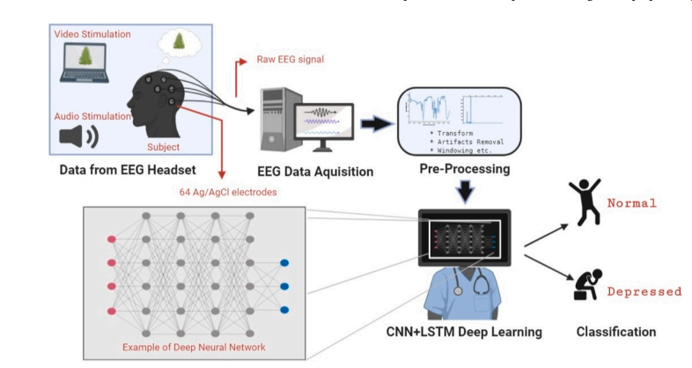
Fig.3.1 Depression detection system using EEG signals.
- Overall Model Architecture
DepHNN (Depression Hybrid Neural Network) is designed as a six-layer deep learning model that effectively captures both spatial and temporal characteristics of EEG signals. The architecture begins with a convolutional layer configured with a kernel size of 64 × 5, which extracts spatial features from the multi-channel EEG input. A ReLU activation function follows to introduce non-linearity and enhance the learning process. The resulting feature maps are passed through two Long Short-Term Memory (LSTM) layers. The first LSTM layer consists of 64 units and returns sequences to allow for comprehensive temporal feature learning. The second LSTM layer contains 32 units and continues the sequence modeling, refining long-term temporal dependencies in the data.
Following the LSTM layers, two fully connected dense layers with 16 neurons each are used, both activated using the ReLU function. These layers perform high-level feature abstraction and additional refinement, preparing the data for final classification.
The output layer includes two neurons with a softmax activation function, enabling binary classification of EEG signals into depressed and non-depressed categories. The model is trained using the Huber loss function to ensure robustness against outliers and optimized with the ADAM optimizer for efficient convergence. This configuration ensures high classification performance while maintaining low computational complexity, making the system suitable for practical and clinical applications.
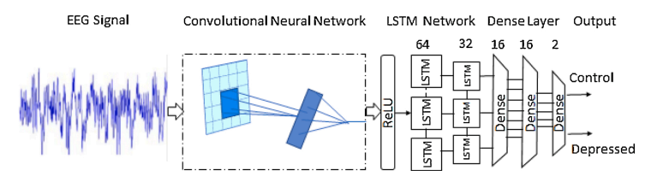
Fig.3.2 Proposed hybrid CNN-LSTM approach for depression detection.
The model is trained using the Huber loss function, which provides robustness against outliers, and the ADAM optimizer, which ensures efficient and adaptive learning. The input EEG data is pre-processed using windowing techniques to divide the continuous signal into fixed-length segments, allowing the model to learn effectively from localized time intervals.
This architecture achieves a balance between accuracy and computational efficiency, making it suitable for real-time deployment in clinical settings or Internet of Medical Things (IoMT) platforms for continuous depression monitoring.

